1)What is maven?

Maven is a powerful project management tool that is based on POM (project object model). It is used for projects build, dependency and documentation.

It simplifies the build process like ANT. But it is too much advanced than ANT.

## 2) What it does?

Maven simplifies the above mentioned problems. It does mainly following tasks.

1. It makes a project easy to build
2. It provides uniform build process (maven project can be shared by all the maven projects)
3. It provides project information (log document, cross referenced sources, mailing list, dependency list, unit test reports etc.)
4. It is easy to migrate for new features of Maven

Apache Maven helps to manage

* Builds
* Documentation
* Reporing
* SCMs
* Releases
* Distribution

# **Maven Repository**

A **maven repository** is a directory of packaged JAR file with pom.xml file. Maven searches for dependencies in the repositories. There are 3 types of maven repository:

1. Local Repository
2. Central Repository
3. Remote Repository

Maven searches for the dependencies in the following order:

**Local repository** then **Central repository** then **Remote repository**.

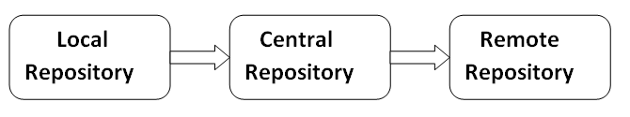

**Maven Lifecycle:**Below is a representation of the default Maven lifecycle and its 8 steps: Validate, Compile, Test, Package, Integration test, Verify, Install and Deploy.

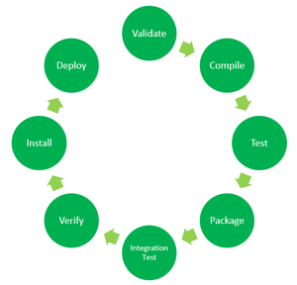

*8 Phases of the Default Maven Lifecycle*

The default Maven lifecycle consists of 8 major steps or phases for compiling, testing, building and installing a given Java project as specified below:

1. **Validate:** This step validates if the project structure is correct. For example – It checks if all the dependencies have been downloaded and are available in the local repository.
2. **Compile:** It compiles the source code, converts the .java files to .class and stores the classes in target/classes folder.
3. **Test:** It runs unit tests for the project.
4. **Package:** This step packages the compiled code in distributable format like JAR or WAR.
5. **Integration test:** It runs the integration tests for the project.
6. **Verify:** This step runs checks to verify that the project is valid and meets the quality standards.
7. **Install:** This step installs the packaged code to the local Maven repository.
8. **Deploy:** It copies the packaged code to the remote repository for sharing it with other developers.

Maven follows a sequential order to execute the commands where if you run step *n*, all steps preceding it (Step 1 to *n-1*) are also executed. For example – if we run the Installation step (Step 7), it will validate, compile, package and verify the project along with running unit and integration tests (Step 1 to 6) before installing the built package to the local repository.

**Maven Commands:**

* **mvn clean:** Cleans the project and removes all files generated by the previous build.
* **mvn compile:** Compiles source code of the project.
* **mvn test-compile:** Compiles the test source code.
* **mvn test:** Runs tests for the project.
* **mvn package:** Creates JAR or WAR file for the project to convert it into a distributable format.
* **mvn install:** Deploys the packaged JAR/ WAR file to the local repository.
* **mvn deploy:** Copies the packaged JAR/ WAR file to the remote repository after compiling, running tests and building the project.